Brief
The main goal of this second worksheet is to task the students with performing an overall descriptive profile of the unemployment rates of across 73 neighbourhoods in Barcelona.
Solution for Question 1
Students must report the summary measures of the unemployment rates and provide the appropriate interpretation to them. Expect to see the following summary measures such as the mean, standard deviation (SD), the interquartile range, as well as the minimum and maximum value.
The interpretation should be along these lines:
The mean unemployment rate in Barcelona was 9.31 (with a standard deviation of ± 3.11). The interquartile range of the distribution for the unemployment rate lies between 7.4 and 10.9. The lowest and highest value for the unemployment rates were 3.6 (Vallvidrera el Tibidabo les Planes) and 19.1 (La Marina del Prat Vermell), respectively.

Solution for Question 2
This question is supposed to challenge the students a bit with some data cleaning and writing of code. They are first expected to filter the dataset down to two districts (i.e., Horta-Guinardo and Nou Barris) before comparing the unemployment rates between them using their neighbourhoods.
This is code for filtering the dataset:
filtered_dataset <- dataset[dataset$District == “Horta-Guinardo” | dataset$District == “Nou Barris” , ]

The above code should filter the data down to 24 neighbourhoods [Horta-Guinardo (11) and Nou Barris (13)]. Note that there’s more than one way to achieve this filter. Next, they should proceed to obtaining the summary estimates for each district and comparing them.
See table below:
Horta-Guinardo | Nou Barris
Mean: 9.01 (SD: ±1.51) [IQR: 8.30-10.15] | Mean: 12.88 (SD: ±2.61) [IQR: 10.9-13.3]

When comparing – they can use the mean and SD for the interpretation to distinguish which district has a higher (or lower) burden of unemployment than the other. In addition, they were also task to show this comparison as a boxplot. The expected output should be a dual box plot like this:
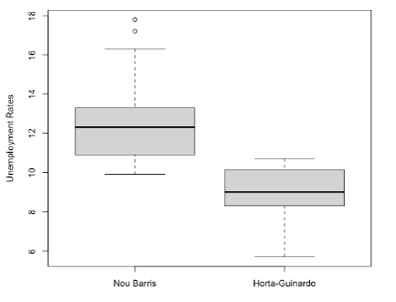
The expected interpretation should look as follows:
Horta-Guinardó has a lower average unemployment rate, with a mean of 9.01% and relatively modest variability (SD ±1.51). Most observed values fall between 8.30% and 10.15%, indicating a fairly stable unemployment level over the period considered. However, Nou Barris shows a substantially higher average unemployment rate, with a mean of 12.88%, alongside greater variability (SD ±2.61). Its interquartile range (10.9% to 13.3%) lies largely above the typical values observed in Horta-Guinardó, suggesting consistently higher unemployment and more pronounced fluctuations.

Overall, unemployment in Nou Barris is roughly 3.9 percentage points higher on average than in Horta-Guinardó, and also more variable. This indicates a marked disparity between the two districts, with Nou Barris experiencing both higher and less stable unemployment levels compared to the relatively lower and more consistent rates in Horta-Guinardó. These are in line with the dual boxplots which are a visual representation of what’s in the above table.

